**Lab_Assignment01_Spring2024**

**CSE370**

**22101593**

**Abrar Mojahid Rafi**

**Section: 05**

**Question 01:**

create table Developers

-> (

-> member_id int,

-> name varchar(30),

-> email varchar(255),

-> influence_count int,

-> Joining_date date,

-> multiplier int

-> );

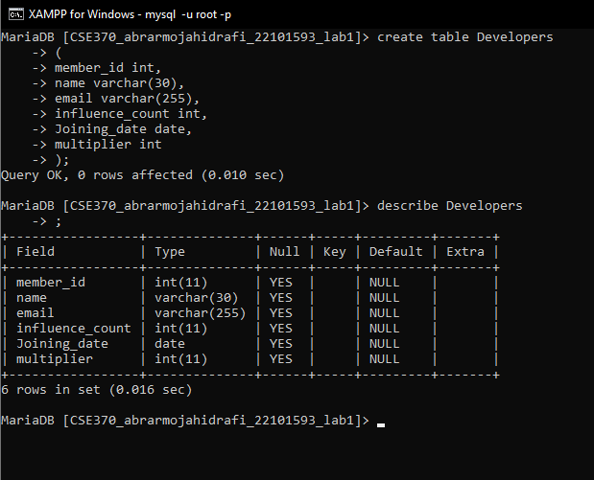

select * from developers;

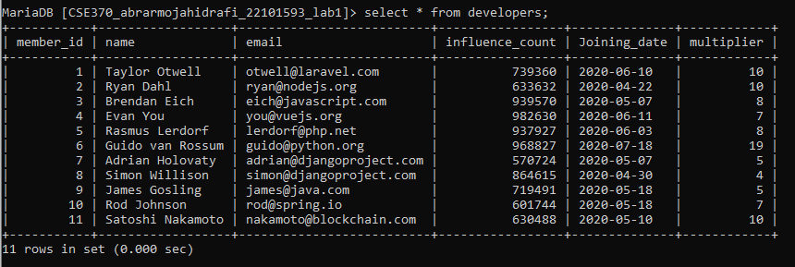

**Question 02:**

alter table developers

-> change column influence_count followers int;

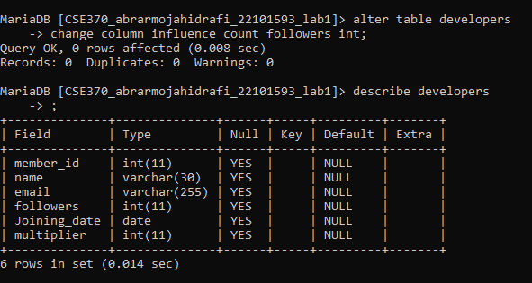

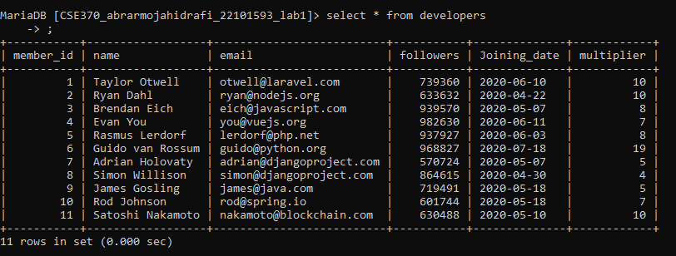

**Question 03:**

update developers

-> set followers = followers + 10

-> ;

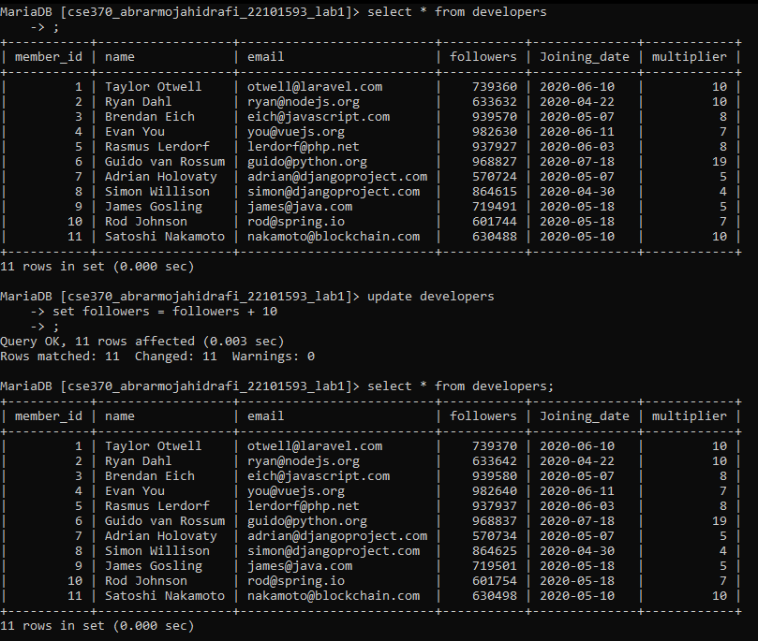

**Question 04:**

SELECT name, ((followers*100/1000000) * (multiplier*100/20))/100 AS Efficiency

-> FROM Developers;

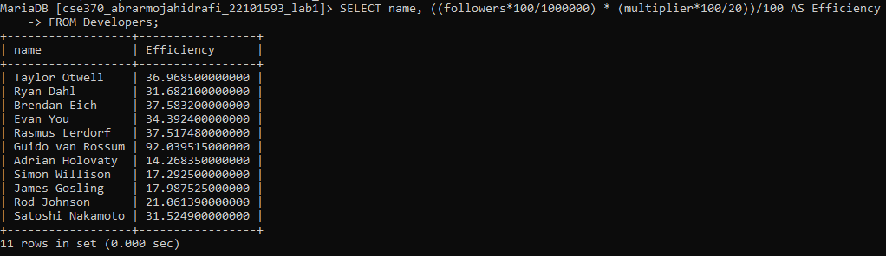

**Question 05:**

select upper(name) as NAME, Joining_date

-> from developers

-> order by Joining_date desc;

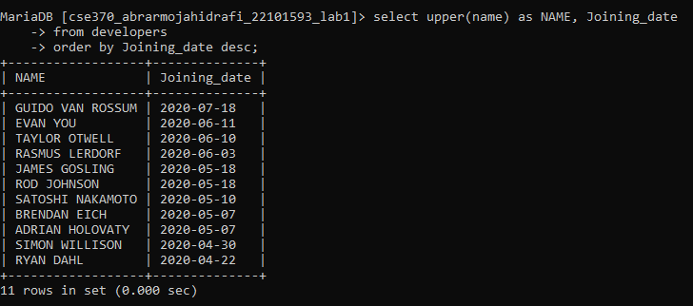

**Question 06:**

select member_id, name, email, followers

-> from developers

-> where email like '%.com' or email like '%.net';

